Making my own Masters in Software Architecture
Hey folks,
I've been struggling to find a good and at a reasonable price Masters in Software Architecture. Because of that, I decided to make my own course. I've been working in the IT industry for several years, but I want to study Software Architecture in a better and formal format.
My course is going to take 1 year of study and some time to write a dissertation (or a book). I'm posting about it because I'd like to check if the courses and books that I'm going to take makes sense for this specialization.
I'll appreciate any feedbacks =)
Btw, I'd love to have an advisor. For now, I just have some friends and people that I work with that could help me with doubts/questions.
Link: https://www.notion.so/Software-Architecture-MSc-58041d9160e14840bae40b25edd1f5b2 (still changing this list)
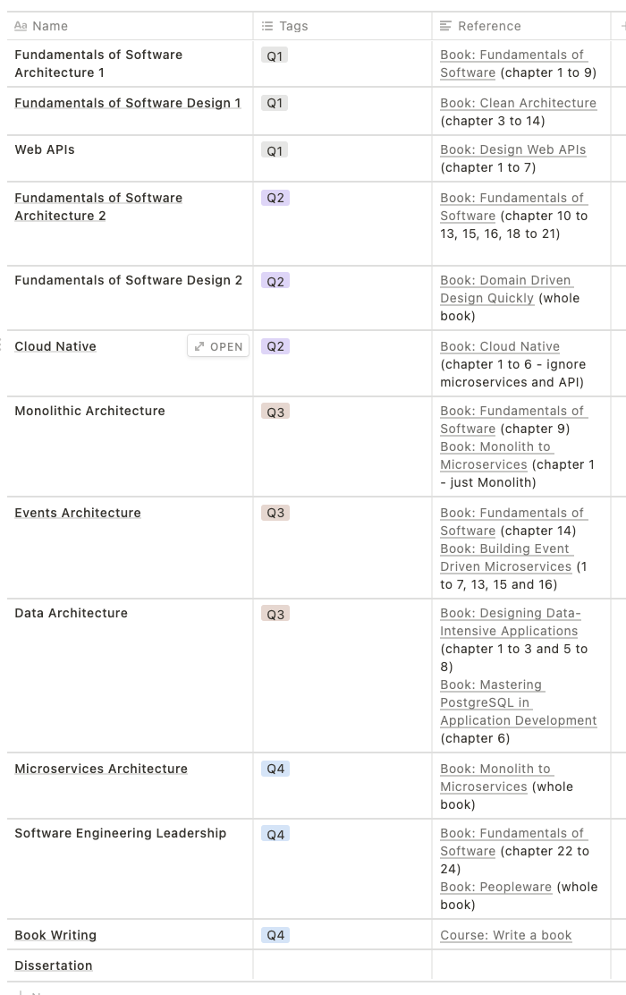
26 comments
96% Upvoted
Log in or sign up to leave a commentLog InSign Up
Sort by



level 1
MrFlibble1138
15 days ago
For software architecture the books I go to are: "Software Architecture in Practice", "Architecting Software Intensive Systems", "Just Enough Software Architecture", "Documenting Software Architectures", "Software Systems Architecture", and all the patterns books.
I'd add sections about UML and other documentation and design approaches. Architecture is also heavily about the user input, so I'd have sections on basic usability and human centered design. Keeping Conway's Law in mind, I'd also have a look at organizational principles and the practicalities of teams.
7



level 2
VerticalEvent
15 days ago
Software Architecture in Practice and Documenting Software Architectures also have courses over at SEI (and throwing in Designing Software Architecture and you have an SEI Software Architecture Professional Certificate).
I did all three about two years ago and I found it pretty effective (looking at going back and doing their Mircoservices certification next, once they open up for in person learning).
3



level 2
lucasvmiguel
15 days ago
Makes a lot of sense, will try to add more content about documentation and the human/organization aspect.
1



level 1
dillonerhardt
15 days ago
This is awesome, are you planning to share the course outline?
3

level 2
lucasvmiguel
15 days ago
https://www.notion.so/Software-Architecture-MSc-58041d9160e14840bae40b25edd1f5b2
2

level 2
lucasvmiguel
15 days ago
Glad that you liked it. Well, the course is pretty much this picture. I'll probably will write a summary after each course fix the ideas.
If you are interested, I can share this page (notion.so) with you.
1
Continue this thread



level 2
akius0
9 days ago
I agree this is awesome
1



level 1
flying_5loths
15 days ago
can you share that link?
3

level 2
lucasvmiguel
15 days ago
https://www.notion.so/Software-Architecture-MSc-58041d9160e14840bae40b25edd1f5b2
1



level 1
martingronlund
15 days ago
I think it's invaluable to consider that a lot of moving parts, e.g. market insight, business strategy, company culture, leadership, software methodology, software architecture and team composition (and probably way more, but this is what comes to mind for me) go hand in hand to support or destroy each other. They have to align.
For this reason I think it's crucial to get a really solid understanding of what makes a great company and start from there. From Good to Great is a very good book, but you can get away with reading a couple of good synopses and thinking hard about what it all means.
Acknowledging that you are a leader and starting from the leadership end, you will be able to align company direction, market strategy, talent growth, business goals, methodology with your architecture, and help the leaders and talent around you make well rooted decisions 😀
E.g. a monolithic hierarchical company which shoehorns "agile" won't thrive with a microservice architecture, despite that being good in and of itself.
3

level 2
lucasvmiguel
14 days ago
You are not the first person to say to study more about organisations and teams. Although my program has some content here and there about organisations, there is no official module about it. Could you recommend courses/books or any content about organisations and teams?
PS: I'm trying to struct each module with around 150~200 pages, so something around that would be ideal. (it doesn't need to be just one book, could be a mix)
1
Continue this thread



level 1
qznc
15 days ago
Some aspects around the technicalities might be helpful. For example, I know a nice little book [0] about some business basics. Concepts like "Return of Investment (ROI)" are useful for architects.
Some measurement and statistics theory might be valuable. I know one [1] which is good for basics and motivation. Another one [2] is great as a reference but I admit they haven't used it in practice yet.
Communication is another big topic but I don't know of any single book or resource to recommend here. I wrote a blog post with some random ideas.
[0] What the CEO Wants You to Know: Using Business Acumen to Understand How Your Company Really Works by Ram Charan, 2001
[1] How to Measure Anything by Douglas Hubbard
[2] Software Estimation: Demystifying the Black Art by Steve McConnell, 2006
2

level 2
lucasvmiguel
15 days ago
Thanks for the suggestions. They definitely look important as a whole, but they might not be as technical as I want. However, they would definitely suit for a support reading.
1



level 1
onety-two-12
15 days ago
This is a great idea.
Make sure you also consider emerging ideas that might make a few of your reading sources obsolete.
https://colossal.gitbook.io/microprocess/a-totally-new-concept/introduction
Disclaimer: I am one of the author's of this draft new standard
3

level 2
lucasvmiguel
15 days ago · edited 15 days ago
definitely! I'll try to study emerging ideas, just need to know more about them.
Thanks for sharing!
2



level 2
Dwight-D
5 days ago
This blew my mind. I’m not finished with the text yet and I still don’t know if I’m convinced, but I’m really intrigued. Very radical stuff, extremely interesting.
1
Continue this thread



level 1
LocksmithSufficient
15 days ago
Does anyone here work for palantir?
1



level 1
veejay-muley
13 days ago
This is awesome. Could you please share the thing with me?
1

level 2
lucasvmiguel
12 days ago
The link is on the description
2
Continue this thread



level 1
iapain
11 days ago
Glad to see Cloud Native. However, "SW Architecture Evaluation Methods/Matrix(s)" are equally useful.

